
Year 8 Mathematics
Project- Review of All Topics

Investigating Apples

All answers need to be neatly written on lined paper and submitted with a cover page!

Background
After visiting a small farm in Gingin, which has exclusively developed a new variety of apple, Alex and Sam decide to open a small shop in a shopping centre to sell these apples. Farmer Joe says he’s happy to provide crates at a reduced price to help encourage people to try the new variety. The apple trees produce mainly red apples but they also produce some green apples. Farmer Joe offers them free small barrels of yellow apples (that grow on a different tree) to help them out. They think it could be a good idea to sell a mixed bag of apples, so that people could get a variety of colours.


Name: ______________________

Teacher: ____________________

Class: _______________________

Part One: Probability

Before opening the shop, Alex and Sam want to find out how much people like apples to make sure their business will be successful. Since it will be a mixed bag, they are particularly concerned with the popularity of green apples and wonder if they are less popular. They decide to visit a local school and survey the Yr 8 cohort (which has 280 students).

- (a) Why is this an example of a sample rather than a census?
(b) Will this give them a good idea of the popularity of apples? Why/why not?

- They decided to ignore the yellow apples as there won’t be many of them. They got students to state whether they liked red apples, liked green apples or liked both as they didn’t have a lot of time. These were their results:

Liked red apples: 225 Liked green apples: 70 Liked both: 50

- Put this information into a two-way table. Example
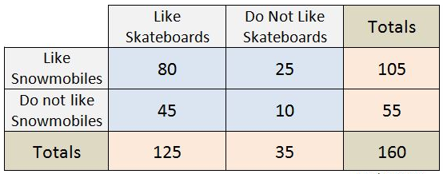
Skate Snow

45 80 25

10

- Now turn this information into a Venn diagram. Example

- Using their two-way table and Venn diagram, they worked out that the amount of students who just liked red apples was 175.
- Use a mathematical sentence to proof this is correct. Eg 150 – 60 = 90
- How many people didn’t like either type of apple?

- As Alex and Sam were leaving, they quickly asked one student (who had kindly stayed behind to help stack the chairs) what were her apple preferences.
- What was the probability that this girl liked both types of apples? (as a fraction)
- What was the probability that this girl liked green apples? (as a decimal)
- What was the probability that this girl didn’t like green apples? (as a percentage)

Extension- Optional
- Alex and Sam concluded from their results that 25% of the bags should be green.
- Is this a fair assumption? Why/why not?
- Conduct your own survey of people you know. Was the fraction of people that liked both types of apples approximately the same? Why might your results be less valid than Alex and Sam’s results?
- It is likely that your results are biased. What does this mean and how could you make your results less biased?

Part Two: Algebra

Alex and Sam decide that enough people like apples and they’re going to give the business a try. They order 4 crates to start, with a mix of red and green apples, and one small barrel of yellow apples. One of Farmer Joe’s workers drops off the first crates but doesn’t know how many apples are in each crate (but does state that there is exactly the same amount in each crate). The worker does remember that Farmer Joe did say there was 650 apples all together.

- Alex and Sam decide to use algebra to help them work out how many apples are in each crate. They decide to use the letter c to represent the amount of apples in a crate.
- What would c – 2 mean in their situation?
- Use an algebraic expression for how many total apples there are in the 4 crates.
- They are told by a friend in the apple industry that you can get 15 bags worth of apples from a crate. They write this algebraically as $\frac{15}{c}$ but are told by their friend they are not quite right. What should the expression look like?

- Alex counts the green apples in one crate and gets a total of 30 green apples. Alex writes the amount of apples in one crate as r + 30.
- What do you think this means?
The Distributive Law
3 (x + 2) = 3x + 6
- Use the distributive law to express the amount of
apples in the 4 crates in terms of r.

- Sam counts the number of yellow apples in the barrel to be 50. Sam writes the equation 4c + 50 = 650 to help work out how many apples there are altogether.
- What does this equation mean in terms of their situation?
- Solve this two-step equation to find the number of apples in a crate.
- They both work out that there must be 120 red apples in each crate. Substitute the number of red apples in each crate and the total apples in each crate into the equation r + 30 = c to prove they are right.

- Alex and Sam think they will divide the crate of apples evenly into 15 bags and wonder how many apples should go in each bag.
- They work out that the number of apples in a crate is therefore b + b + b + b + b + b + b + b + b + b + b + b + b + b + b (where b is the number of apples in a bag). What is a better way of writing this?
- Write an algebraic expression to state how many apples there are in all 4 crates in terms of b.
- How many apples will be in each of the 15 bags? Hint: Use your answer in Q3

Extension
- Some the apples in the crates are damaged so Alex and Sam decide to put them in separate bags (to be sold as cooking apples).
- If d is the number of damaged green apples and there are 5 times more damaged red apples than green, write algebraic expression for the number of apples from the crate that will be used for the normal bags.
- If there 138 apples per crate used for the normal bags, how many damaged red apples are there per crate?
Part Three: Number Skills

For each crate, Alex and Sam have noticed that on average 6 out of the 30 green apples are damaged, 24 out of the 120 red apples are damaged and in the barrel 2 out of the 50 yellow apples are damaged (the barrel is more sturdy).

- (a) What fraction of the green apples are generally damaged? Remember to simplify
(b) Alex says the damaged red apples represent 0.2 of the overall amount. Show how Alex got this number.
(c) These two numbers are said to be in proportion. What does this mean?
(d) Sam says 2% of the yellow apples are damaged but this is not quite right. What should the number actually be?

- After removing the damaged apples (to be sold cheaper as cooking apples), the amount of normal apples left, written as a ratio of red:green:yellow, is 96:24:12 (the remaining 48 yellow apples is divided into 4, some for each crate). Alex and Sam need to simplify this number to find out how many of each type should go in a bag.
- If Alex halved all the numbers, 96:24:12, what would this new ratio be?
- Sam halved the numbers again and then divided them all by a number and got 8:2:1 (which is as simple as possible). What is the number Sam divide by?
- Sam and Alex could have just divided by the highest common factor (the largest times table that all 3 of those number are in) in the first place to get that simplified ratio. What number is the highest common factor for these numbers?

- Since Alex and Sam must remove the damaged apples from a crate, they realise that they will only be able to make 12 bags per crate, with 8 red apples, 2 green and 1 yellow in each bag.
- How many red apples will be needed for 2 bags of apples?
- How many green apples will be needed for 7 bags of apples?
- How many bags will they be able to make with their 4 crates?
- What is the total amount of apples used to for the amount of bags in (c)?
- Given they had been sent 650 apples to begin with, how many will be sold off as cooking apples?

Extension
- Alex and Sam are unsure how to sell off the remaining cooking apples (ie how many in a bag and how many of each colour in the bag). Set out how you would do it (note: the bags may not be even)

Part Four: Measurement

The apples in each crate (rectangular prisms) are neatly arranged in rows and levels. Alex and Sam realise that there’s a lot of wasted space in the crates and wonder what is the volume of this space. To do this they must know the volume of the crate and the volume of the apples.

- The crate has 50 apples per level. Each level has the apples arranged 5 by 10.
- Draw a diagram of one level (from an above view).
- Each apple is 7cm wide (and 7cm long). This means the crate would be 70cm long and how many centimetres wide?
- The apples happen to be 7cm high as well, making them perfectly spherical. What does spherical mean?
- If the height is 21cm (each level is 7cm high), how many levels does the crate have?
- The volume of the crate is calculated by multiplying the length by the width by the height (V = l × w × h). Farmer Joe had told them already that the answer is about 50 000 cm³. Calculate the exact answer.

- The formula of the volume of a sphere is V = $\frac{4}{3}$ × π × r³ which means if Alex and Sam know the radius (r) of an apple, they can find the volume of the apple.
- $\frac{4}{3}$ is equal to 1.3333… where the 3 is recurring. What does recurring mean?
- π is an irrational number called pi that is often used with circular shapes. Write down pi to 7 decimal places (7 digits after the point, don’t forget to round).
- r² means the radius squared which could also be written as r × r (radius multiplied by itself). For the formula above, we need r³. How would this be written?
Volume of an eraser = 10cm³
Volume of a brick = 2000 cm³
- Alex and Sam decide to estimate the volume of the apple
first so that they are less likely to make a mistake.
- Estimate the volume of a standard apple. Hint
- If the width of an apple is the same as the diameter (7cm) and the radius is half the diameter, what is the radius of an apple?
- Alex entered the calculation 1.3 x 3.14 x (3.5 x 3) into their calculator but Sam said Alex did 3 things wrong. If the volume of an apple is 179.59 cm³ (or about 180cm³), what were those things? Write the correct calculation.

- To work out the volume of the wasted space they must subtract the volume of all the apples from the volume of the crate.
- If the volume of one apple is 180cm³, what is the volume of all the apples in the crate? Remember there are 5 levels of apples and each level is 3 by 10
- Use the approximate volume of the crate (50 000cm³) to work out the approximate wasted space in the crate.
- What is the amount using the exact crate volume?
- Which number, (b) or (c), do you think Alex and Sam would use when telling Farmer Joe the amount of wasted space in a crate? Why?

Extension
- To decrease the amount of damaged apples in the delivery process, Alex wondered whether the crates could be a different shape.
- Sam pointed out that different shapes may be less space efficient. Why did Sam mean by this?
- Investigate some other crate shapes such as a triangular prism, cylinder, etc and come up some dimensions that still give a volume of about 50 000cm³
- Which shape design would you choose to have if you were Alex and Sam? Why?
Part Five: Rates and Linear Relationships

To ensure they will make enough money, Alex and Sam want to investigate how much they will need to charge per bag.

- (a) If the crates cost Alex and Sam $36 each (the barrels are free) and they can get 12 bags of normal apples per crate, how much will it cost to produce one bag?
(b) If there are 11 apples per bag, how much would each apples cost?
(c) Alex and Sam may want to sell apples by weight. Alex weighs an apple to be 70g and calculates the price of apples to be nearly $4/kg. How did Alex calculate this rate?

- They decide that if a bag costs them $3, they should charge the public $5 per bag.
- How much profit would they make per bag?
- The percentage profit (pp) can be calculated by the formula $\frac{profit}{orginal price}$ × 100. If the original price is $3, what is the pp they will make per bag?
- Alex says that the profit per crate is $24. How did Alex calculate this number?
- Sam says the pp per crate is the same as the pp per apple. Why is this?

- The rent Alex and Sam will pay for their shop is $200 per week. They want to work out how many crates they need to sell in a week to ‘break even’ (profit = rent). They decided to set up a table to help them using the equation:
Overall Profit = $24 x Number of crates – Rent

- Alex simplifies the equation to this: p = 24c – 200. How would Alex use this equation to fill in the table?
- Sam says that if the c = 0 then p = -200. Use the context of the situation to explain what this means.
- Draw out this table and fill in the blanks.

No. of Crates | 0 | 1 | 2 | 3 | 4 | 5
Overall Profit | -200 | -176 |  |  | -104

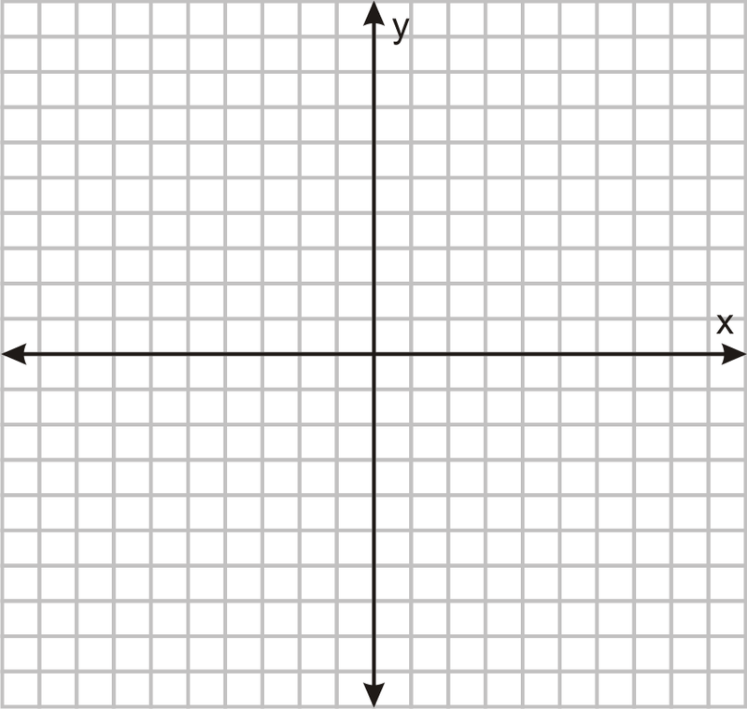
- Alex and Sam want to graph this linear relationship so they can see how many crates they need to sell to break even.

(a) Draw a Cartesian plane. Example
(b) Put the number of crates (c) on the x-axis and the
profit (p) on the y-axis. Make the y-axis go up by $20.
(c) Plot each point and then continue the line so
that it goes well past the x-axis
- If they sold 10 crates they would get $240 from the
sales. Once rent is taken out the overall profit will be
$40. What is the minimum amount of crates that need
to be sold so that the profit is still a positive number?
- What would there overall profit be if they sold 100 crates?

Extension
- (a) What is the gradient and y-intercept of this relationship?
(b) What would it mean if the gradient was negative in this context?
(c) What would it mean if the y-intercept was positive in this context?
(d) Why would Alex and Sam not want either of these two things?

Part Six: Time and Data

The time has come for Alex and Sam to open the shop. They decide their opening hours will be 8am- 5:30pm Monday-Friday, Saturday 8:30am- 4pm, Sunday 10am- 3pm.

- (a) How many hours are they open for on a week day?
(b) How much more time are they open for on a Saturday compared to Sunday?
(c) Their total opening hours for the week is 60. Show a mathematical sentence to prove this is correct. Eg Hours = (6 x 5) + 5.5 + 4

- The amount of crates sold per day for the first 4 weeks can be seen in the table below.

Week | Mon | Tues | Wed | Thurs | Fri | Sat | Sun
1 | 0 | 1 | 2 | 2 | 1 | 2 | 0
2 | 3 | 4 | 2 | 2 | 2 | 3 | 2
3 | 5 | 3 | 4 | 3 | 2 | 5 | 3
4 | 6 | 5 | 4 | 0 | 2 | 4 | 3

- How many crates did the sell on Monday week 1? Why is this so low?
- If each crate makes 12 bags of apples, how many bags were sold on Tues week 2?
- If there are 11 apples per bag, how many apples did they sell on Sat week 3?
- If they needed to sell 9 crates in a week to break even, how many of the weeks did they break even on?

- Alex and Sam want to analyse their data. They think using a dot plot might be good idea for their data.
- Why is a dot plot better than a stem and leaf graph or a histogram?
- Draw a dot plot of their results.
- Alex calculates the mean (average). This is done by adding up the total sales and dividing by the number of days. Work out the mean of the sales for their data.
- Sam gets the mode and the median mixed up. In this case, one is 2 and the other is 2.5. Which one is which? Show working or reasoning.
- Thursday week 4 is significantly lower than most others after week 1. What do we call a value that is quite different from the others?
- Given Monday week 1 was the 1st December, why might sales have been lower on this day?

Extension
- Alex and Sam notice some trends in the data. There seems to be certain days of the week that have lower or higher sales than other.
- Which day of the week has the highest total sales over the 4 weeks?
- Ignoring the first week when they were still new, which day of the week has the highest average sales and what is that average?
- Why do you think Fridays seem to have lower sales?
- Do you think their sales are increasing over time? Draw a column graph to prove this.

Part Seven: Shape

Alex and Sam think they could improve their sales if they did some marketing. They decide they need a snazzy new name and logo to grab people’s attention at the shopping centre.

- Alex saw a fun picture of an orange on the internet (example)
and thought they could do something like that. Alex settles on
a pentagonal apple-person but isn’t very good at drawing.
Have a go at one to help Alex out.


- Sam thought something a bit classier, like this one on a local juice shop.
Sam draws one that is the same but bigger to show Alex.
Is Sam’s drawing an example of congruency or similarity? Why?

- Alex and Sam cannot decide on their new name and logo. The name must be catchy and relate to apples (as it is an apple shop) and the logo needs to have something to do with apples as well. Create a name and logo for Alex and Sam to use. You can use this name and logo on your cover page.

Extension
- Alex and Sam want to put an advert in the local paper with their newspaper to get more people aware of their new shop. Design an advert, which includes the new name and logo, which will make people want to come to their shop.

